## Reports/Inventory Reports/Inventory Adjustment

Request:

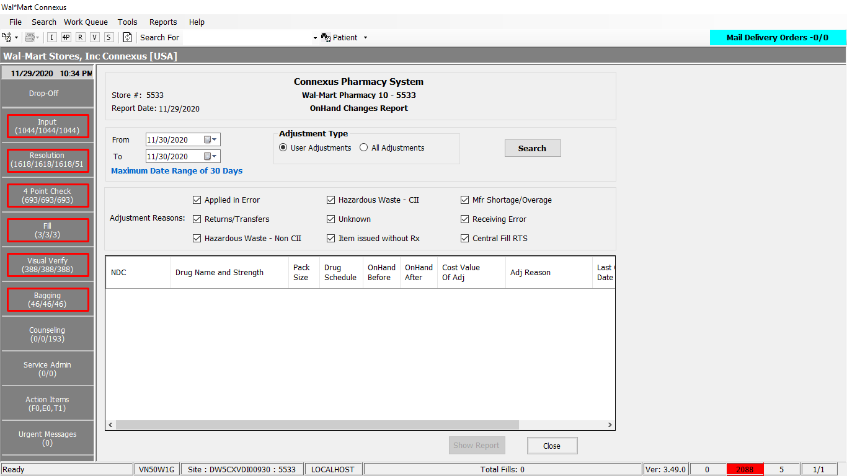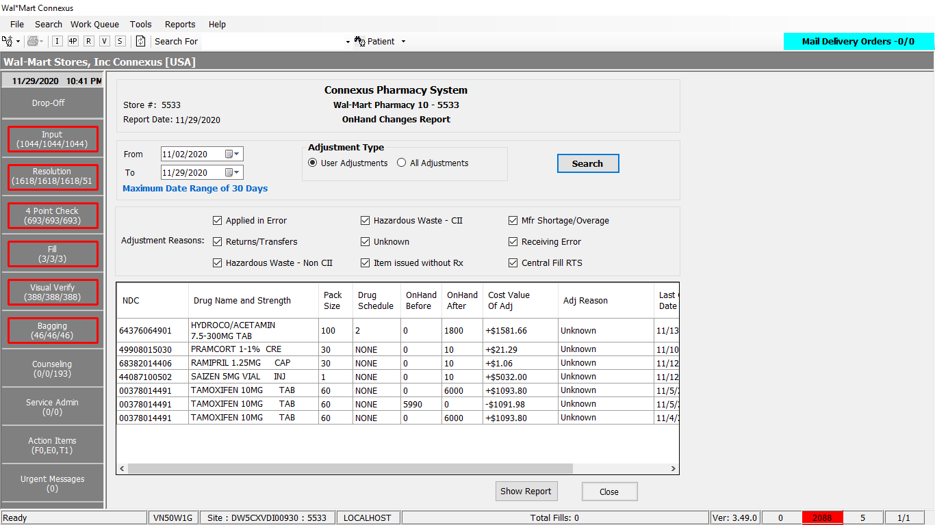

Response:

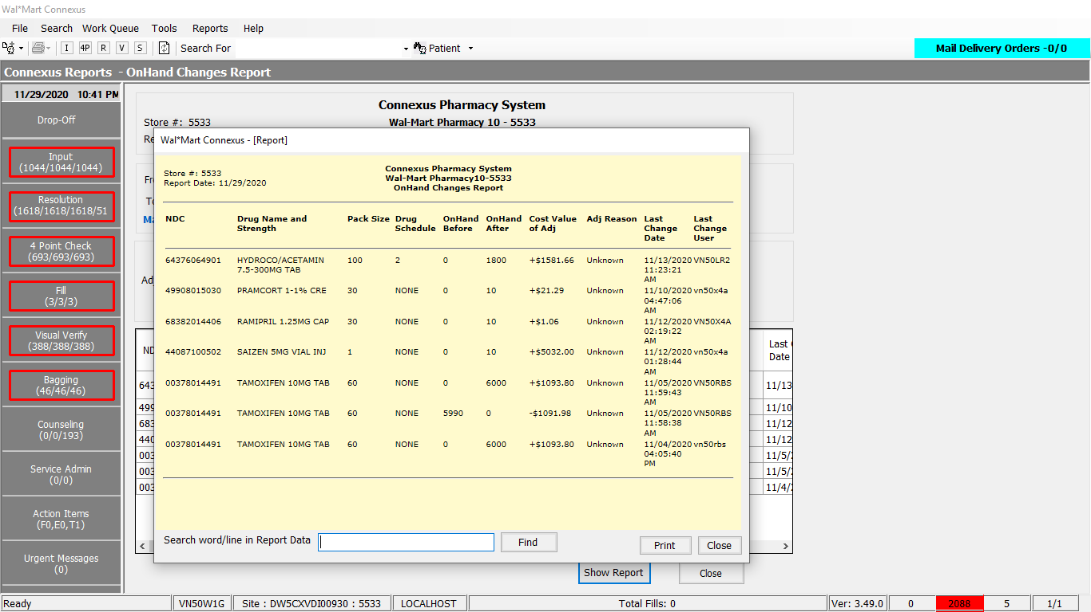

Query:

Friend Const GetChangedOnHandsData1stPart As String = " SELECT tab.ndc_nbr, " _

& " tab.DrugName, " _

& " tab.PackSize, " _

& " tab.OnHndBfr, " _

& " tab.OnHndAfr, " _

& " tab.OnHndChgTs, " _

& " tab.OnHndChgId, " _

& " tab.adjustmentcost, " _

& " tab.drugschedule, " _

& " Case When tab.adjmtrsncode=2 Then CONCAT(trim(tab.adjmtreason),'-CII') " _

& " WHEN tab.adjmtrsncode=8 THEN CONCAT(trim(tab.adjmtreason),'-Non CII') ELSE tab.adjmtreason END adjmtreason, " _

& " Case When tab.AdjmtTypeCode In (6604,6605) And tab.adjmtrsncode Is null Then 6 " _

& " Else tab.adjmtrsncode " _

& " End adjmtrsncode " _

& " FROM ( " _

& " Select pi.ndc_nbr, pp.short_name DrugName, (pi.outer_pack_qty * pi.inner_pack_qty) PackSize, " _

& " pil.prev_onhand_qty OnHndBfr , pil.onhand_qty OnHndAfr , pil.adjmt_ts OnHndChgTs, pil.adjmt_userid OnHndChgId , " _

& " pil.adjmt_type_code adjmttypecode, " _

& " Case When (pil.onhand_qty- pil.prev_onhand_qty) >= 0 " _

& " Then CONCAT('+',cast(((pil.onhand_qty- pil.prev_onhand_qty)*pic.phm_item_cost_amt) as decimal(12,2))) " _

& " When (pil.onhand_qty- pil.prev_onhand_qty) < 0 " _

& " THEN CONCAT('',cast(((pil.onhand_qty- pil.prev_onhand_qty)*pic.phm_item_cost_amt) as decimal(12,2))) END adjustmentcost, " _

& " dct.drug_control_abbr drugschedule, pil.log_id, piial.adjmt_rsn_code adjmtrsncode," _

& " CASE WHEN pil.adjmt_type_code IN (?,?) AND piial.adjmt_rsn_code IS NULL THEN " _

& " (SELECT (adjmt_rsn_desc) FROM pharmacy_offering:phm_item_Adjmt_rsn_txt WHERE adjmt_rsn_code=?) " _

& " WHEN piial.adjmt_rsn_code Is Not NULL THEN piarst.adjmt_rsn_desc ELSE NULL END adjmtreason " _

& " FROM pharmacy_offering:pharmacy_item pi JOIN pharmacy_offering:pharmacy_product pp On ( pp.product_mds_fam_id = pi.product_mds_fam_id ) " _

& " JOIN pharmacy_offering:phm_item_inv_adjmt_log pil On ( pil.mds_fam_id = pi.mds_fam_id And Date(pil.adjmt_ts) >= ? AND date(pil.adjmt_ts) <= ? "

Friend Const GetChangedOnHandsDataFilterCondition As String = " And adjmt_type_code In (?,?) And adjmt_userid Not Like ('%AUDIT%') " &

" AND adjmt_userid not LIKE ('%GHOST%') "

Friend Const GetChangedOnHandsData2ndPart As String = " ) " _

& " JOIN pharmacy_offering:drug_control_text dct On ( dct.drug_control_code= pp.drug_control_code ) " _

& " JOIN pharmacy_offering:phm_item_cost pic On ( pic.mds_fam_id = pil.mds_fam_id And pic.cost_type_code = 3001 " _

& " And pic.effective_date = (Select MAX(effective_date) FROM pharmacy_offering:phm_item_cost pic2 WHERE " _

& " pic2.mds_fam_id=pic.mds_fam_id And pic2.cost_type_code = 3001)) " _

& " JOIN pharmacy_offering:phm_item_inv_adjmt_log piial On ( piial.log_id = pil.log_id ) " _

& " LEFT OUTER JOIN pharmacy_offering:phm_item_Adjmt_rsn_txt piarst On ( piial.adjmt_rsn_code = piarst.adjmt_rsn_code )) tab " _

& " WHERE tab.adjustmentcost <> 0 "

Friend Const GetChangedOnHandsDataSortCondition As String = " ORDER BY tab.DrugName, tab.ndc_nbr, tab.log_id DESC "

DAL:

Public Function GetChangedOnHandsData(ByVal siteId As Integer, ByVal StartDate As Date,

ByVal EndDate As Date, ByVal includeAllAdjustments As Boolean) As List(Of ChangedOnHandInfoBE) Implements IReportDAL.GetChangedOnHandsData

Using (New Tracer(ConnexusCommonConstants.ConnexusTracer))

'Inventory Changes - Start

Dim sqlString As New StringBuilder

Dim changedOnHandInfoList As New List(Of ChangedOnHandInfoBE)

sqlString.Append(ReportQueries.GetChangedOnHandsData1stPart)

Dim paramList As New List(Of DbParameter)

'Include positive adjustment.

paramList.Add(ParameterHelper.BuildParameter("POH", DbType.Int32, AdjTypeCode.POH))

'Include negative adjustment.

paramList.Add(ParameterHelper.BuildParameter("NOH", DbType.Int32, AdjTypeCode.NOH))

paramList.Add(ParameterHelper.BuildParameter("ReasonCode", DbType.Int32, ServicesCommonConstants.UnknownReason))

paramList.Add(ParameterHelper.BuildParameter("StartDate", DbType.Date, StartDate))

paramList.Add(ParameterHelper.BuildParameter("EndDate", DbType.Date, EndDate))

'If User Adjustment options is selected, include only positive and negative adjustments done by users.

If Not includeAllAdjustments Then

sqlString.Append(ReportQueries.GetChangedOnHandsDataFilterCondition)

'Include positive adjustment.

paramList.Add(ParameterHelper.BuildParameter("POH", DbType.Int32, AdjTypeCode.POH))

'Include negative adjustment.

paramList.Add(ParameterHelper.BuildParameter("NOH", DbType.Int32, AdjTypeCode.NOH))

End If

sqlString.Append(ReportQueries.GetChangedOnHandsData2ndPart)

'Include the sort condition DrgName, NDC Number , Adjustment Timestamp

sqlString.Append(ReportQueries.GetChangedOnHandsDataSortCondition)

Dim dataReader As IDataReader = ExecuteReader(DatabaseEnum.rx21c, siteId, sqlString.ToString(), paramList)

'Inventory Changes - End

While dataReader.Read

Dim changedOnHandInfo As New ChangedOnHandInfoBE

If Not dataReader.IsDBNull(dataReader.GetOrdinal("ndc_nbr")) Then

changedOnHandInfo.NDCNumber = Convert.ToString(dataReader("ndc_nbr"), CultureInfo.InvariantCulture)

End If

If Not dataReader.IsDBNull(dataReader.GetOrdinal("DrugName")) Then

changedOnHandInfo.DrugName = Convert.ToString(dataReader("DrugName"), CultureInfo.InvariantCulture)

End If

If Not dataReader.IsDBNull(dataReader.GetOrdinal("PackSize")) Then

changedOnHandInfo.PackSize = Convert.ToDecimal(dataReader("PackSize"), CultureInfo.InvariantCulture)

End If

If Not dataReader.IsDBNull(dataReader.GetOrdinal("OnHndBfr")) Then

changedOnHandInfo.OnHandQtyBefore = Convert.ToDecimal(dataReader("OnHndBfr"), CultureInfo.InvariantCulture)

End If

If Not dataReader.IsDBNull(dataReader.GetOrdinal("OnHndAfr")) Then

changedOnHandInfo.OnHandQtyAfter = Convert.ToDecimal(dataReader("OnHndAfr"), CultureInfo.InvariantCulture)

End If

If Not dataReader.IsDBNull(dataReader.GetOrdinal("OnHndChgTs")) Then

changedOnHandInfo.OnHandChangedTS = Convert.ToDateTime(dataReader("OnHndChgTs"), CultureInfo.InvariantCulture)

End If

If Not dataReader.IsDBNull(dataReader.GetOrdinal("OnHndChgId")) Then

changedOnHandInfo.OnHandChangedId = Convert.ToString(dataReader("OnHndChgId"), CultureInfo.InvariantCulture)

End If

changedOnHandInfo.AdjustmentCost = dataReader.GetValueOrDefault(Of String)("adjustmentcost")

changedOnHandInfo.AdjmtReason = dataReader.GetValueOrDefault(Of String)("adjmtreason").SafeTrim()

changedOnHandInfo.DrugSchedule = dataReader.GetValueOrDefault(Of String)("drugschedule").SafeTrim()

changedOnHandInfo.AdjmtRsnCode = dataReader.GetValueOrDefault(Of Int32)("adjmtrsncode")

changedOnHandInfoList.Add(changedOnHandInfo)

End While

If changedOnHandInfoList.Count = 0 Then

Return Nothing

End If

Return changedOnHandInfoList

End Using

End Function